**AIR QUALITY MONITORING**

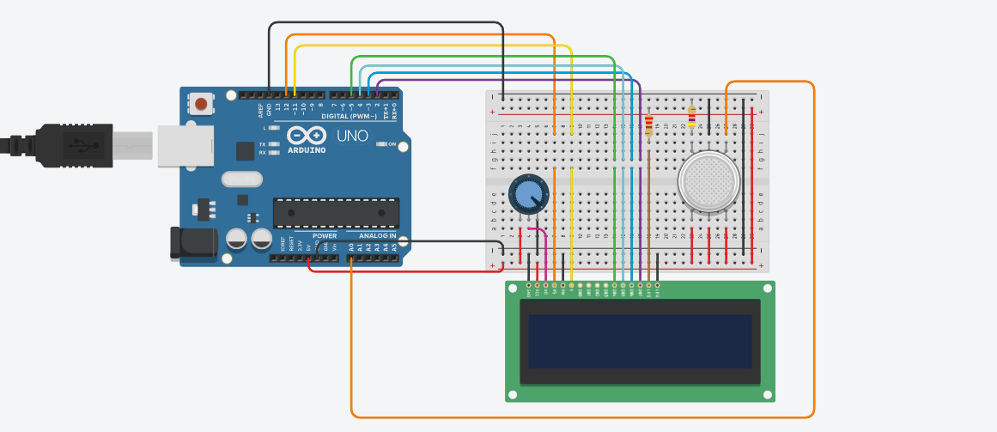

**CODE:**

import time

import board

import adafruit_character_lcd.character_lcd_rgb_i2c as character_lcd

# Initialize the LCD library

lcd_columns = 16

lcd_rows = 2

i2c = board.I2C()

dlcd = character_lcd.Character_LCD_RGB_I2C(i2c, lcd_columns, lcd_rows)

analog_pin = board.A0

def setup():

lcd.message = "What is the air\nquality today?"

lcd.display = True

def loop():

lcd.clear()

val = analog_pin.value

print(val) # Debug value

if 0 < val <= 306:

lcd.message = "Normal"

elif 307 <= val <= 420:

lcd.message = "Gas Detected"

elif 421 <= val <= 520:

lcd.message = "Dense Gas"

lcd.set_cursor_pos(0, 1)

lcd.message = "Detected"

elif 521 <= val <= 724:

lcd.message = "EMERGENCY!"

while True:

loop()

time.sleep(0.1)

**DEFINITION:**

**Import necessary libraries:**

import time

import board

import adafruit_character_lcd.character_lcd_rgb_i2c as character_lcd

These lines import the required libraries, including **time** for timing operations, **board** for hardware control, and **adafruit_character_lcd** for interfacing with the character LCD.

**Initialize the LCD library:**

lcd_columns = 16

lcd_rows = 2

i2c = board.I2C()

lcd = character_lcd.Character_LCD_RGB_I2C(i2c, lcd_columns, lcd_rows)

* The **lcd_columns** and **lcd_rows** variables define the dimensions of the LCD screen.
* An I2C object is created to communicate with the LCD.
* The **character_lcd.Character_LCD_RGB_I2C** class is used to initialize the LCD.

**Define the analog pin:**

analog_pin = board.A0

This line defines the analog pin (**A0**) to which the gas sensor is connected.

**Setup function:**

**def setup():**

**lcd.message = "What is the air\nquality today?"**

**lcd.display = True**

**The setup() function initializes the LCD by setting the initial message ("What is the air quality today?") and enabling the display.**

**Loop function:**

**def loop():**

**lcd.clear()**

**val = analog_pin.value**

**print(val) # Debug value**

**if 0 < val <= 306:**

**lcd.message = "Normal"**

**elif 307 <= val <= 420:**

**lcd.message = "Gas Detected"**

**elif 421 <= val <= 520:**

**lcd.message = "Dense Gas"**

**lcd.set_cursor_pos(0, 1)**

**lcd.message = "Detected"**

**elif 521 <= val <= 724:**

**lcd.message = "EMERGENCY!"**

**The loop() function clears the LCD screen, reads the analog value from the gas sensor, and prints it for debugging.**

**Based on the value read, it displays different messages on the LCD screen to indicate air quality.**

**The lcd.set_cursor_pos(0, 1) method is used to move the cursor to the first column of the second row before displaying "Detected."**

**Main loop:**

**while True:**

**loop()**

**time.sleep(0.1)**

**The main loop repeatedly calls the loop() function.**

**After each iteration, it waits for 0.1 seconds using time.sleep(0.1) before the next iteration.**